**CTS DIGITAL NURTURE - 4.0 JAVA FSE**

**WEEK 8 - GIT**

**1.Git HOL1**

* **Setup your machine with Git Configuration**
* **Integrate notepad++.exe to Git and make it a default editor**
* **Add a file to source code repository**

**1.To check if Git client is installed properly**

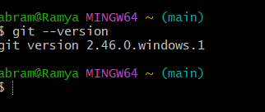

**2.To check if the configuration is properly set**

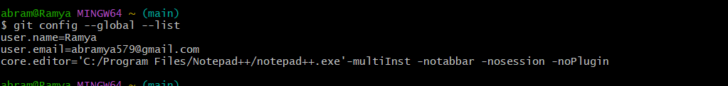

**3.Integrate notepad++.exe to Git and make it a default editor**

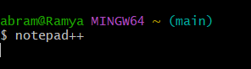

**OUTPUT:**

Notepad++ opens automatically.